Guidelines for ALL Strategy
Collaboration & Innovation Fund
Funding Call 2023

Table of contents

Introduction 3
Overarching principles of the fund 4
Conditions of funding 4
Application process 5
Funding evaluation criteria 6
Appraisal Process and Marking System 6
Allocation of funding 7
Reporting requirements 7
Appendix 1- Support Network in Ireland
Appendix 2 – ALL Strategy target cohorts
Appendix 3 - ALL Regional Literacy Co-Ordinator Contact Details
Appendix 4 - Terms and Conditions of Funding

Introduction

The Adult Literacy for Life (ALL) Strategy was launched in September 2021 and sets out an ambitious 10-year strategy to transform adult literacy, numeracy and digital literacy in Ireland. It takes a whole of society approach to creating awareness of the importance of literacy and is a key step in achieving Ireland’s goal of a fully inclusive and equitable society and economy. The Strategy aims to ensure that every adult has the necessary literacy, numeracy and digital literacy to fully engage in society and realise their potential.

The ALL Strategy makes a number of commitments including:
- Increasing the number of learners engaging with literacy and language support by 20,000 over the first half of the strategy’s lifetime;
- Reduce the number of adults in Ireland with unmet literacy needs, from 18% to 7%.
- Reduce the number of adults in Ireland with unmet numeracy needs from 25% to 12%;
- Reduce the share of adults in Ireland without basic digital skills from 47% to 20%.

One of the specific objectives of the ALL Strategy is a themed call for proposals focused on collaborative and innovative proposals in adult literacy, numeracy and/or digital literacy that address unmet needs, with particular emphasis on certain cohorts identified in the strategy. Therefore, applications are required to come from at least two separate entities with one lead applicant submitting the application. The call is being managed by SOLAS which has overall responsibility for the ALL National Programme Office. The ALL Strategy is overseen by a Cross-Government Implementation Group.
These guidelines provide the following:
- The overarching principles of the fund
- Conditions of funding
- Application process
- Funding evaluation criteria
- Allocation of funding
- Reporting requirements

Overarching principles of the fund

The purpose of the ALL Strategy Collaboration & Innovation Fund is to support collaborative and innovative practice in the area of unmet literacy, numeracy and digital literacy needs.

For 2023, there is an open call for proposals that public and non-profit organisations will submit directly to SOLAS. However, applicants are advised to consult with the Regional Literacy Coordinators in their area (list of current Coordinators attached in Appendix 3). The role of the Regional Literacy Coordinators (RLCs) is to work with stakeholders at a local level, as well as colleagues across the education, health, community development & local government supports & services. The aim is to embed the required systems-based approach to addressing unmet literacy needs. Cross-society partnerships and collaboration are essential for the successful implementation of the ALL Strategy.

It should be noted that any proposed projects should have no adverse impact on existing services or provision funded through SOLAS, Education and Training Boards and/or other state agencies. It must not duplicate existing services.

Conditions of funding
Governance
The lead applicant organisation must ensure that funding allocated under the ALL Strategy Collaboration & Innovation Fund is used for the approved purpose and in compliance with all statutory, European Union and other obligations that apply as set out in the Terms and Conditions (please refer to Appendix 4).

For 2023, the total funding available under the fund is €1 million. The maximum grant awarded to any application will be €50,000. There is no minimum amount that may be applied for. The amount of the grant awarded will be dependent on the nature and quality of the proposal. Eligible costs will include direct costs and programme costs and indirect overhead costs. Indirect costs should not exceed 10% of the direct cost of the project.

Please note that any content and/or material produced will be jointly owned by the ALL National Programme Office for further dissemination, use, and development (with full acknowledgement included). Please note that this call is stand alone and separate to the REACH Fund.

Expenditure
Approved funding allocation for any project under the ALL Strategy Collaboration & Innovation Fund must:
- be used for the specific purpose intended,
- be expended by 2023 year-end,
- not be used for costs of a recurring nature that extend beyond the year end 2023,
- all unspent monies must be returned to SOLAS.

SOLAS will manage the application process and will consider for funding proposals that meet the aims of the ALL Strategy. The proposal must have an emphasis on collaboration and innovation.

Application process
- Organisations are invited to make an application under the criteria set out in these guidelines.
- Funding applications must be submitted in electronic form directly to SOLAS to allinnovation@solas.ie
- Applications must be received by 5 pm on 14th April 2023. Applications received after this date cannot be accepted.
- Successful applicants will receive 80% of the grant on confirmation of project approval. The remaining 20% will issue upon receipt of a final project report. This will include a Balancing Statement which will reflect actual spend and will be used to recoup any unspent money.
- Where the lead applicant onward grants, it should ensure that it receives an invoice from any partner organisation which details the costs incurred by that partner.

Appraisal Process and Marking System
The ALL Strategy Collaboration and Innovation Fund applications will be screened in the first instance by SOLAS to ensure they meet the criteria set out in this funding call. Proposals that meet the criteria will then be considered by an independent expert panel. Applicants must have clearly identified and demonstrated the need for their project proposals.
The criteria and scoring under which every application will be assessed is as outlined below.

The maximum marks available is 160. Please note that the ALL Strategy is a national strategy and consideration will be given to a balanced geographical spread. Applicants should also be aware that there is a limit on the amount of funding for 2023 and this may impact the level of funding successful applicants receive.

Funding Criteria
Criteria
 |  |  | Essential | Marks Available
A | The application supports the aims of the ALL Strategy to address unmet adult literacy/ numeracy/digital literacy needs. |  |  | 30
B | The application proposes collaborative and innovative approaches with other organisations. |  |  | 30
C | The proposal targets are:
 | C.1 | Identified cohorts under ALL Strategy. |  | 15
 | C.2 | Other adults with unmet literacy/numeracy/digital literacy needs. |  | 5
D | The application will break down barriers to engagement with people with unmet literacy, numeracy or digital literacy needs. |  |  | 20
E | The application has clear and demonstratable positive outcomes. |  |  | 20
F | The degree to which the applicant has demonstrated  the impact their project proposal will have on unmet need |  |  | 20
G | The degree to which the applicant can demonstrate how the grant will have a direct added value to unmet literacy, numeracy or digital literacy needs and not duplicate existing services in their area. |  |  | 20

Other Requirements
Organisations must be tax compliant and provide a Tax Clearance Access Number along with the Tax Reference Number and Charity Number (where applicable).

Capital Threshold
Furniture and Equipment up to €1,000 inclusive of VAT. Where equipment is purchased, they come under the ownership of the applicant organisation (grantee). If equipment is being loaned out by the applicant organisation, there should be a loan scheme and policy in place and proper records maintained.

Allocation of funding
SOLAS in determining the allocation of funding under this fund, will ensure the following factors are satisfied:
- All governance requirements and assurances on how this funding would be spent, if approved, have been satisfied.
- There is no duplication of State funding.
- Terms and Conditions of funding are complied with.

Reporting requirements

SOLAS will require a final report on the outcomes at the end of the project, including confirmation of spend.

SOLAS may ask for additional evidence of how the grant has been spent and retains the right to seek further supporting documentation.

Closing date for receipt of applications is Friday 14th April 2023 at 5pm

Closing date for receipt of applications is 2023 at 5pm

Appendix 1 – Support Networks in Ireland

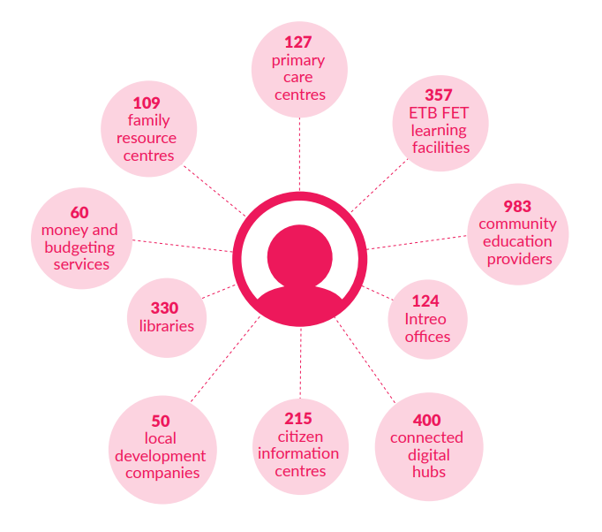

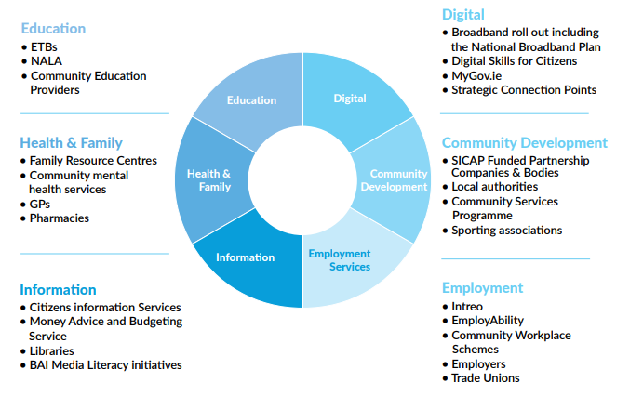

Appendix 2 – ALL Strategy cohorts*

List of ALL strategy cohorts
Older adults (55+)
Members of the traveller community
People with disabilities
One-parent households
Low paid workers
Carers
Long-term unemployed
Migrants
International protected applicants
People with language needs
Incarcerated persons and ex-offenders
Persons recovering from addiction

* These cohorts were identified during the strategy development process that are most in need of focused support.

Appendix 3 – Contact Details for ALL Regional Coordinators (as of March 2023)
Education & Training Board | Regional Literacy Coordinator | Email | Telephone
Cavan & Monaghan Education & Training Board | Ceinwen Fergus | ceinwenfergus@cmetb.ie | 087 068 7841
Cork Education and Training Board | Sinead Maloney | sinead.maloney@corketb.ie | 086 084 3030
City of Dublin Education & Training Board | Andrew Connolly | andrew.connolly@aes.cdetb.ie | 086 601 8180
Donegal Education & Training Board | Adele McElhinney | adelemcelhinney@donegaletb.ie | 086 084 9284
Dublin and Dun Laoghaire Education & Training Board | Sinead Hyland | sineadhyland@ddletb.ie | 087 979 0888
Galway and Roscommon Education & Training Board | Bernadette Smith | Bernadette.smith@gretb.ie | 087 7636260
Kerry Education & Training Board | Paula Tiller | paula.tiller@staff.kerryetb.ie | Temporary phone number: 087 337 2139
Kildare and Wicklow Education & Training Board | Deirdre Gallagher | deirdregallagher@kwetb.ie | 087 1884355
Kilkenny and Carlow Education & Training Board | Helen Walsh | helenm.walsh@kilkennycarlowetb.ie | 087 767 5547
Laois and Offaly Education & Training Board | Ann Shields | ashields@loetb.ie | 085 8760327
Limerick and Clare Education & Training Board | Síle O’Riordan | sile.oriordan@lcetb.ie | 086 022 4375
Longford and Westmeath Education & Training Board | Deirdre Clarke | DClarke@lwetb.ie | 085 8010883
Louth and Meath Education & Training Board | Niamh McShane | nmcshane@lmetb.ie | 086 1373979
Mayo, Sligo and Leitrim Education & Training Board | Thomas Howley | thomashowley@msletb.ie | 085 748 2365
Tipperary Education & Training Board | Ester Mackey | emackey@tipperaryetb.ie | 087 062 6937
Waterford and Wexford Education & Training Board | Edel Finan | edelfinan@wwetb.ie | 086 084 5354

Appendix 4 Terms and Conditions

Please see current ALL Collaboration & Innovation Fund Terms & Conditions document for full details.

